Thank you for contributing to educating a child through Bachpan Banao. Following are the steps to donate to this cause:

1. Get started by clicking on “click here to DONATE” button on [this](https://bachpanbanao.com/sponsor-a-child/) page

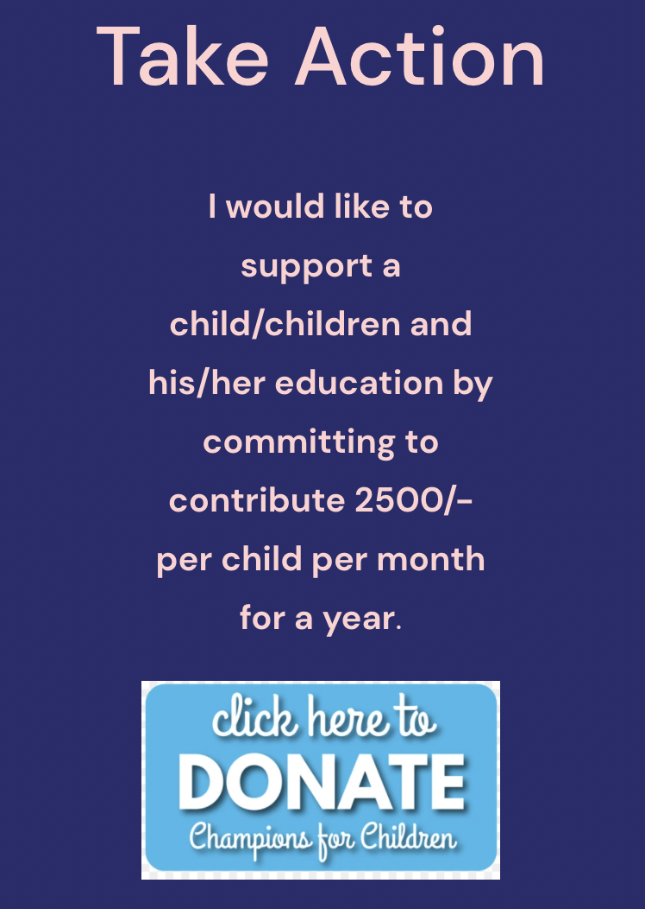

1. You will land on the following page which will allow you to make a donation of your choice.  
    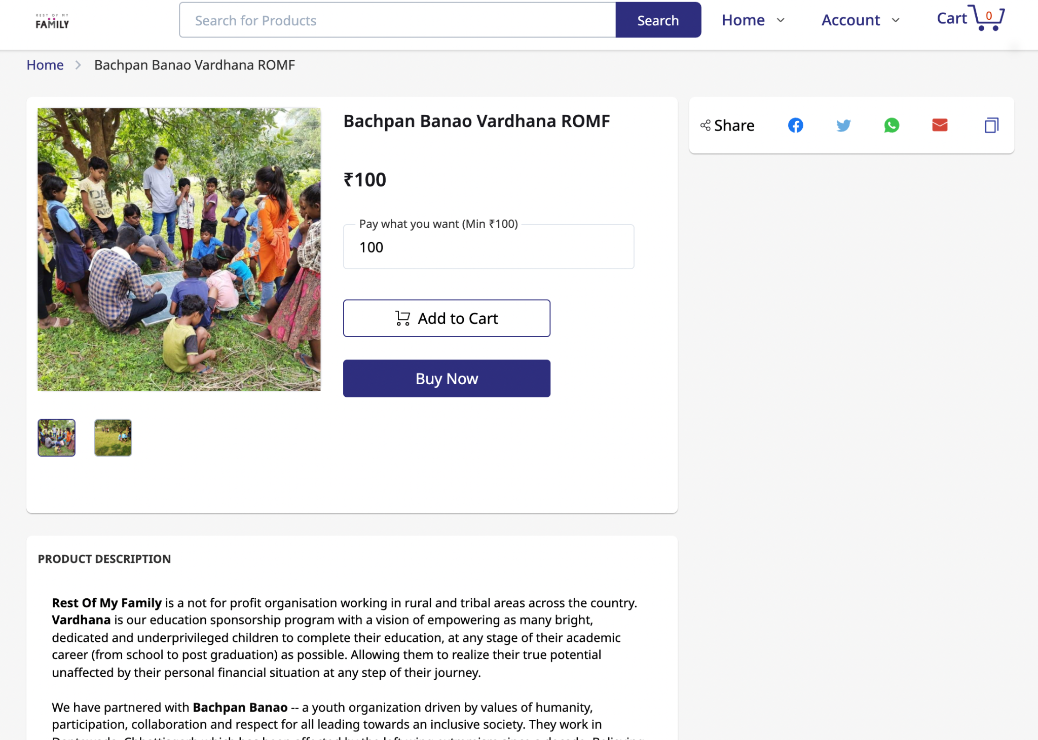
2. Choose an amount you wish to donate:
   1. Rs. 2500 - this will cover **one month**’s cost of sponsoring a student’s education
   2. Rs. 30,000 - this will cover **one year**’s cost of sponsoring a student’s education
   3. Rs. 24,00,000 - this will cover **one year**’s cost of sponsoring 80 student’s education
   4. Rs. XXX - any amount you wish to donate

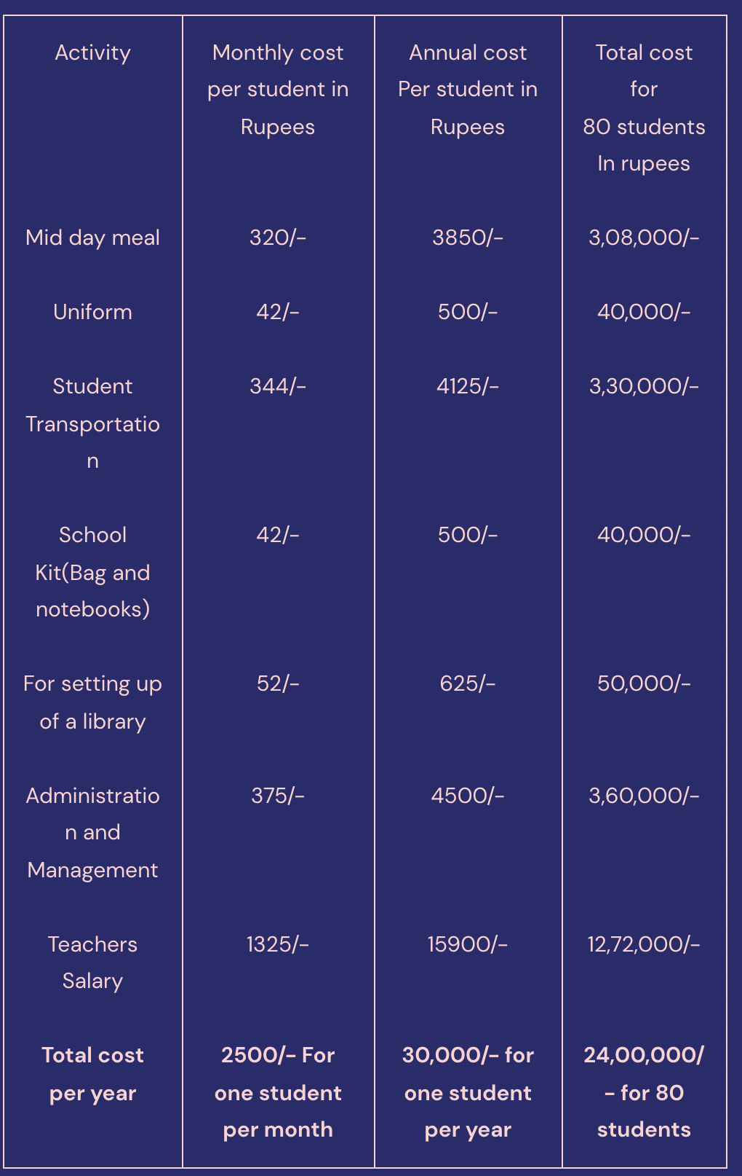

For example, let’s choose Rs. 30000. Enter the amount and then click on “Buy Now”

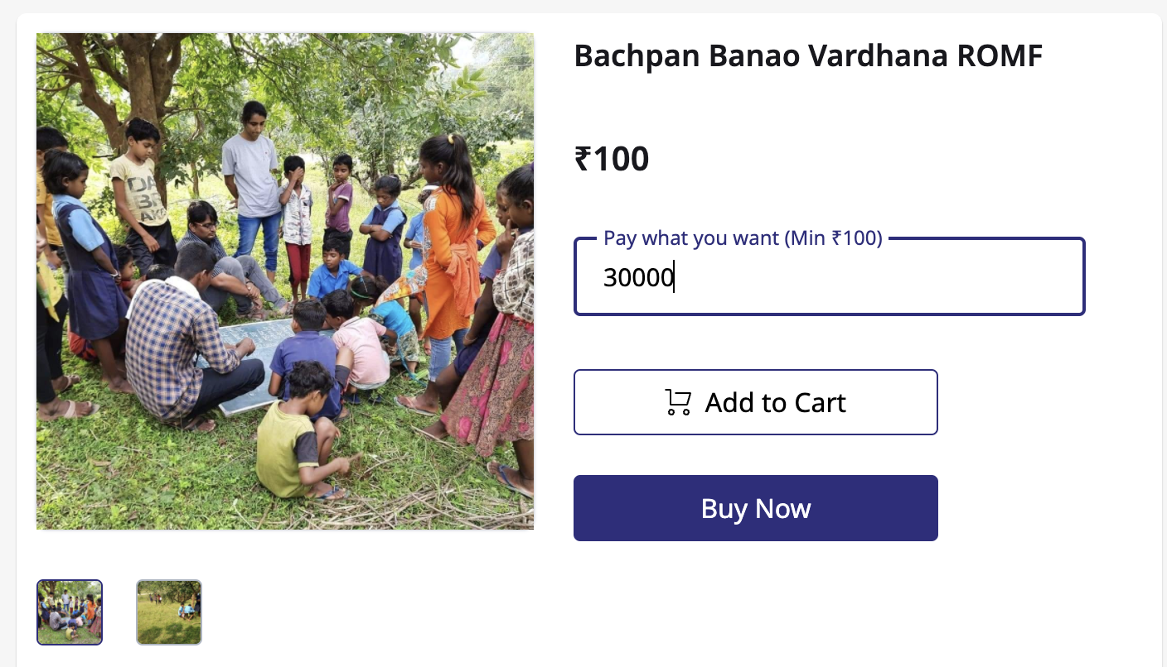

1. You will land on the “Customer Information” Page. Fill in your relevant details here

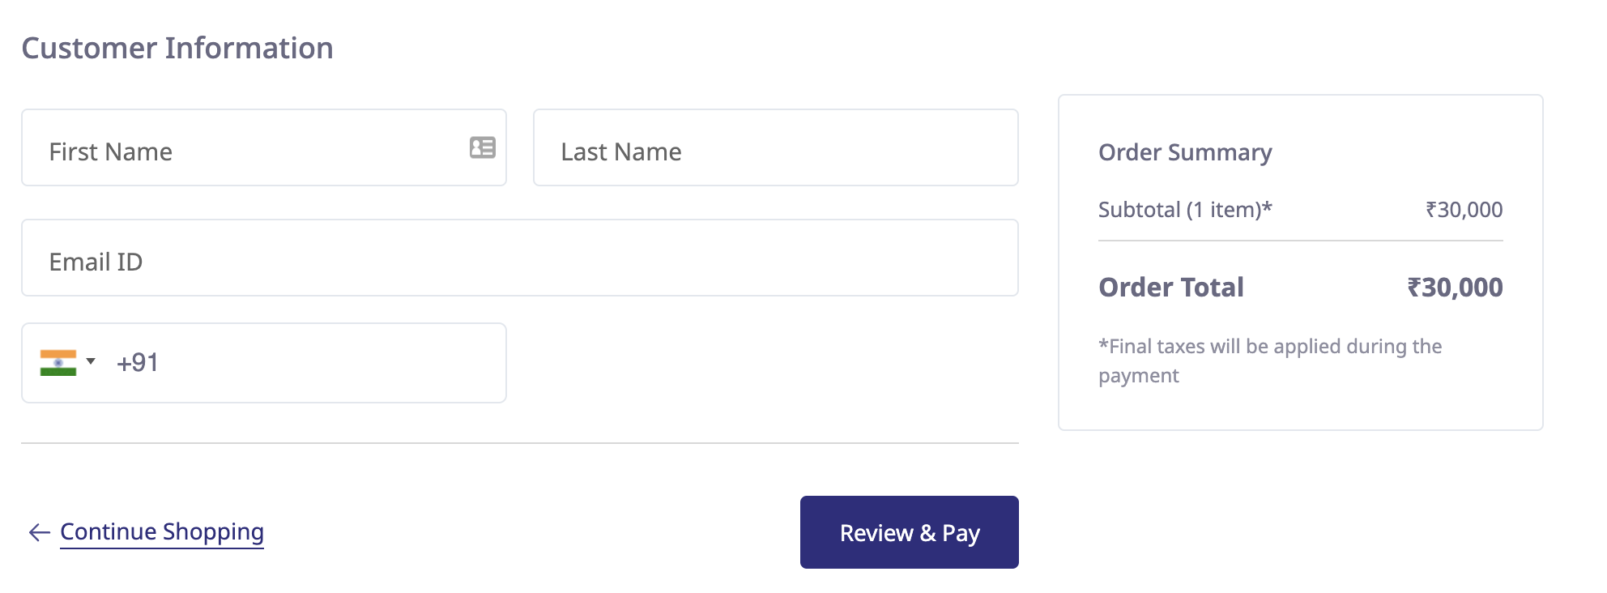

And click on “Review and Pay”

1. Review your order

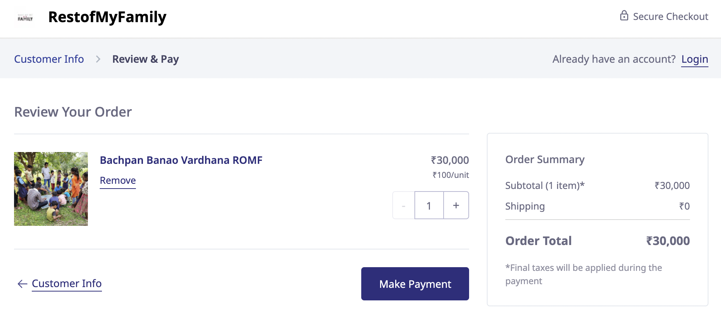

And click on “Make Payment”

1. Next, you will land on the page where you can make a payment using one of the multiple options

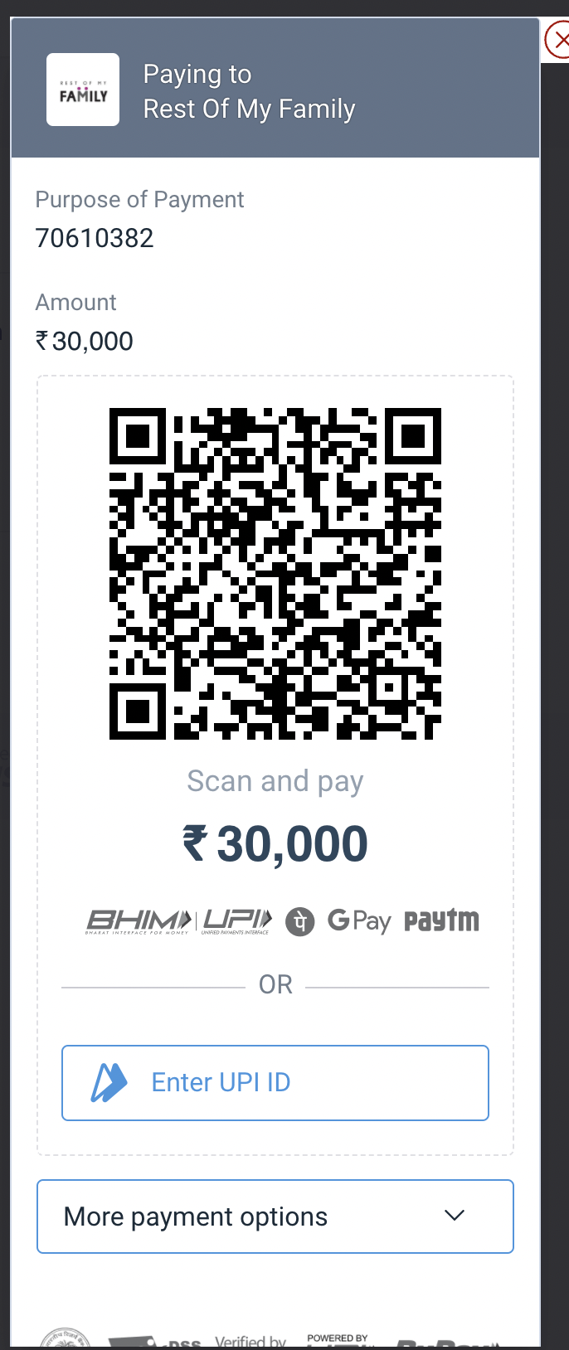

If you do not have BHIM, UPI, GPay or PayTM, you can use other options to make a payment as well. Following is the list of other options:

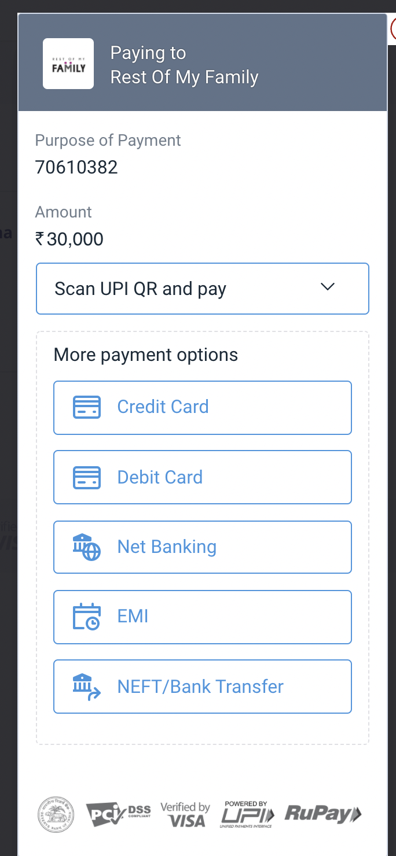

1. Once you have made a payment, you should receive the order completion updates on your email and phone number that you provided as a part of your Customer Information in Step 4.

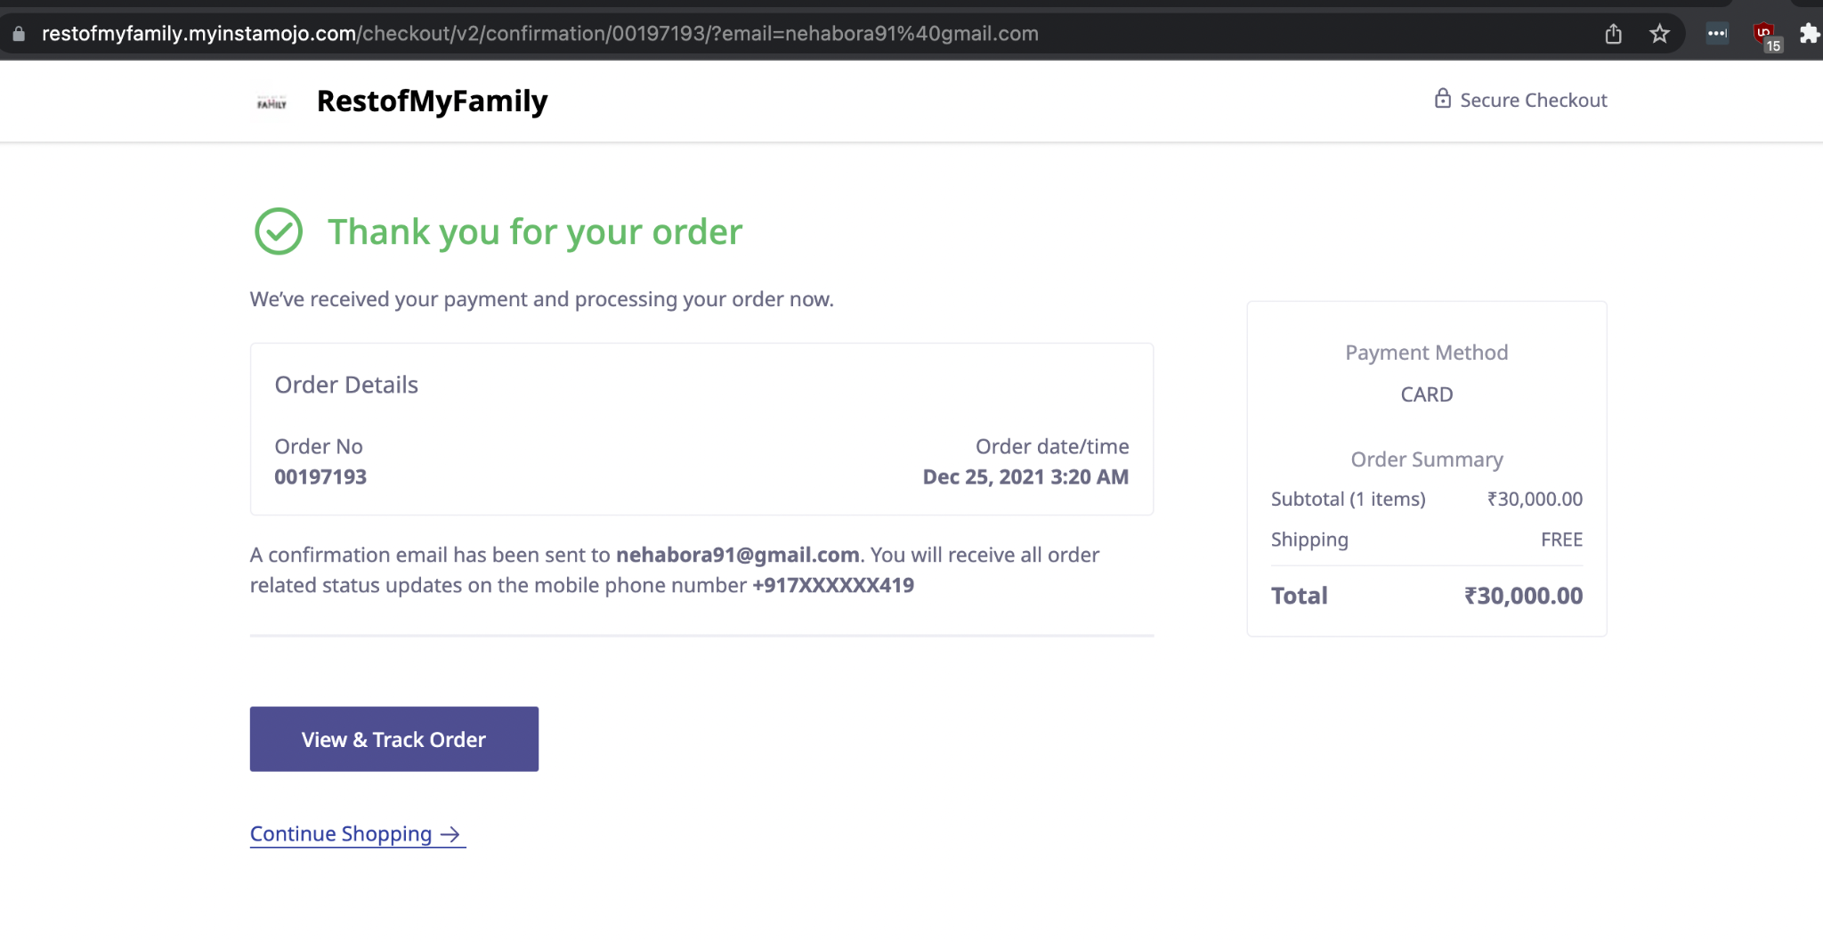

Confirmation email of the order

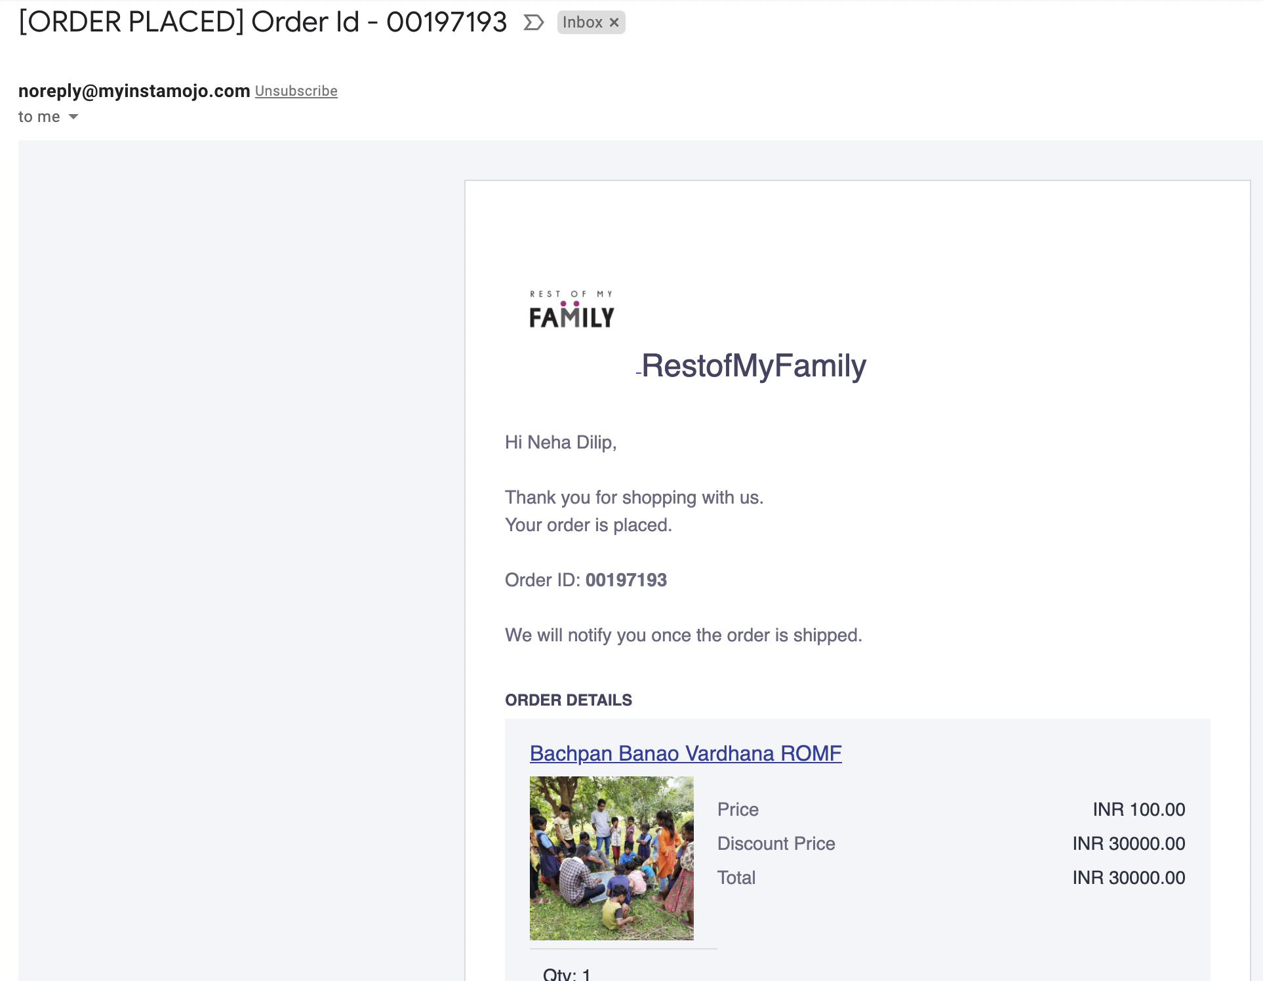

Payment confirmation email from instamojo

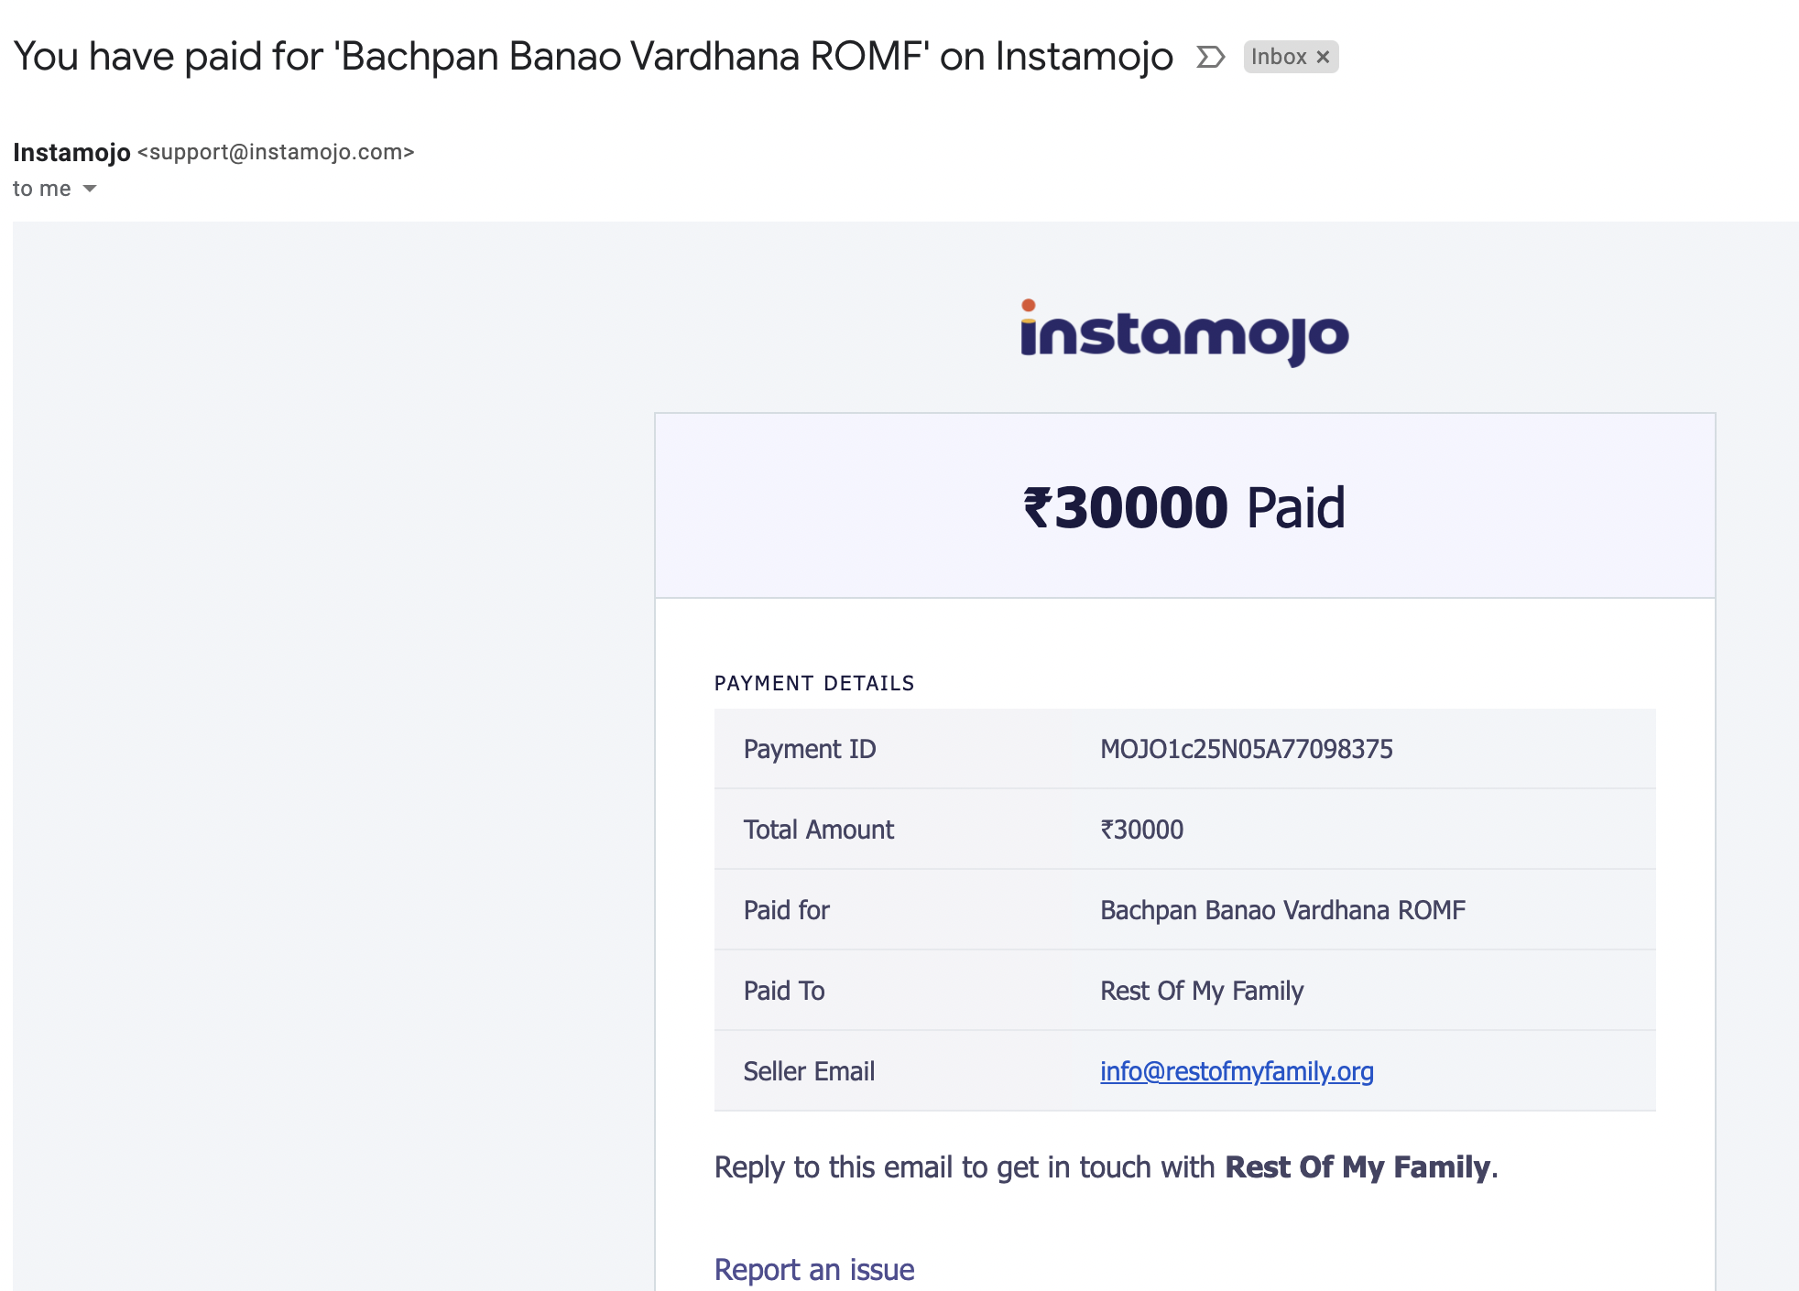

Thank you for sponsoring a student’s education. We will keep you updated with the progress your contribution has made possible.